The future of ChatGPT: How will ChatGPT impact the world?

Introduction
The Chat Generative Pretrained Transformer (released on November, 2022), also referred to as Chat GPT, is a chatbot that combines artificial intelligence (AI) with natural language processing (NLP) technology to generate responses to user queries that resemble human conversations. Applications of Chat GPT includes comprehending natural language and produce meaningful, contextually appropriate responses, producing premium content rapidly and saving time and effort involved in manual content generation, assisting to overcome language barriers by offering translations, etc.,

ChatGPT Trend

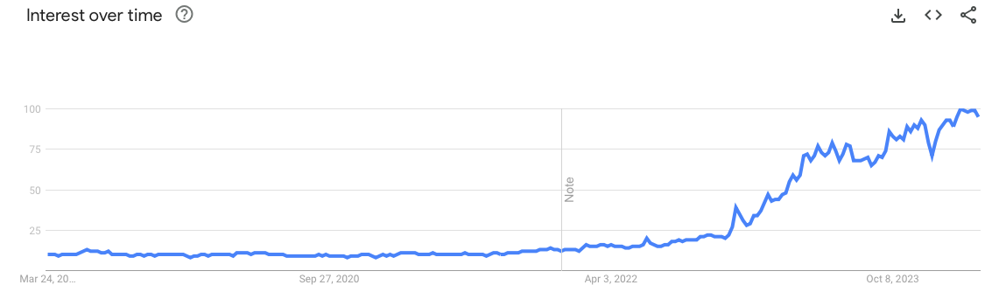
Figure: 1.1 (Source: Google Trend) Graph depicts the interest in Artificial Intelligence (AI) topic across the world for the past 5 year. It is crucial to note that, while ChatGPT was released in November 2022, there has been a long-standing interest in AI.

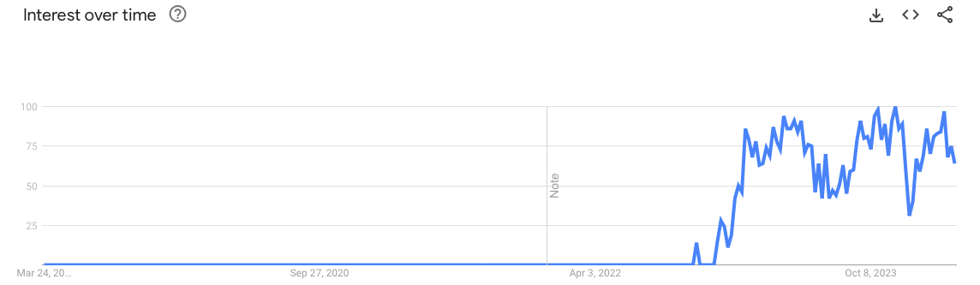

Figure: 2.1 (Source: Google Trend) Graph depicts the interest in The Future of ChatGPT topic across the world for the past 5 years
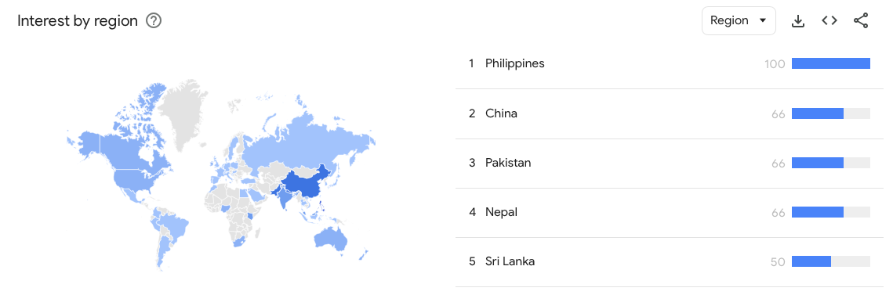

Figure: 1.2 (Source: Google Trend) Graph depicts the country-wise interest in The Future ChatGPT topic across the world for the past 5 years

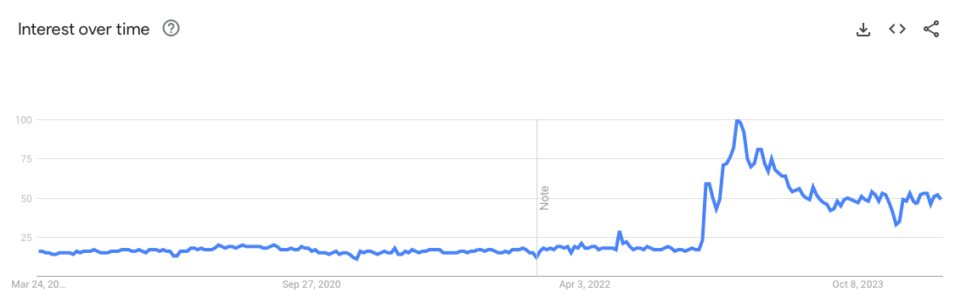

Figure: 1.3 (Source: Google Trend) Graph depicts the country-wise interest in Chatbot topic across the world for the past 5 years.

Overview of the study
While we recognize the impact the ChatGPT has/going to make, it is very important to understand the influence in detail by assessing the impact, investments in ChatGPT, limitations, ethical concerns, effects on the Workforce and the future of ChatGPT.
As an aspiring Data Scientist, I would like research the following questions have been carefully chosen for analysis; each question will be investigated individually and used as supporting evidence for analysis in subsequent parts.

- What role will ChatGPT play on business enterprise?
- Will more investment in ChatGPT help achieve better outcome in healthcare?
- What are the limitations of ChatGPT and ethical concerns surrounding ChatGPT?
- How ChatGPT will impact the Workforce?
- What are the next chapters of Chat GPT?

Analysis

Role of ChatGPT play on business enterprise

What are the ways that ChatGPT will streamline business operations?

While studying the impacts of ChatGPT on business operations is crucial, it is evident that straightforward business tasks like data entry, appointment scheduling, and managing schedule conflicts can be effectively handled with ChatGPT. This, in turn, offers employees opportunities to acquire new skills and contribute more effectively to the business.

What do we measure the effectiveness of ChatGPT in business enterprise?

While the data around effectiveness of ChatGPT in Business Enterprise is not abundant we can get an indication of effectiveness of the tool by analysing the Sales numbers of ChatGPT and the volume of job offers fulfilled for ChatGPT skillset.

OpenAI is a private company and they do not disclose their sales revenue, but according to estimates, the revenue is in the rise

OpenAI revenues reached $1.6 billion in 2023, with most of it coming from ChatGPT subscriptions and enterprise usage (Curry, 2024).

Year | Revenue ($mm)
2022 | 100
2023 | 1600

Data Source: Estimates

OpenAI has seen its valuation rapidly increase over the past year, with Microsoft’s $10 billion investment valuing the start-up at $29 billion (Curry, 2024).

Date | Valuation ($bn)
December 2022 | 20
February 2023 | 29

Data Source: Estimates (Valuation)

It is evident that the employers are showing increasing interest in prospective candidate with knowledge and skillset around Generative AI.

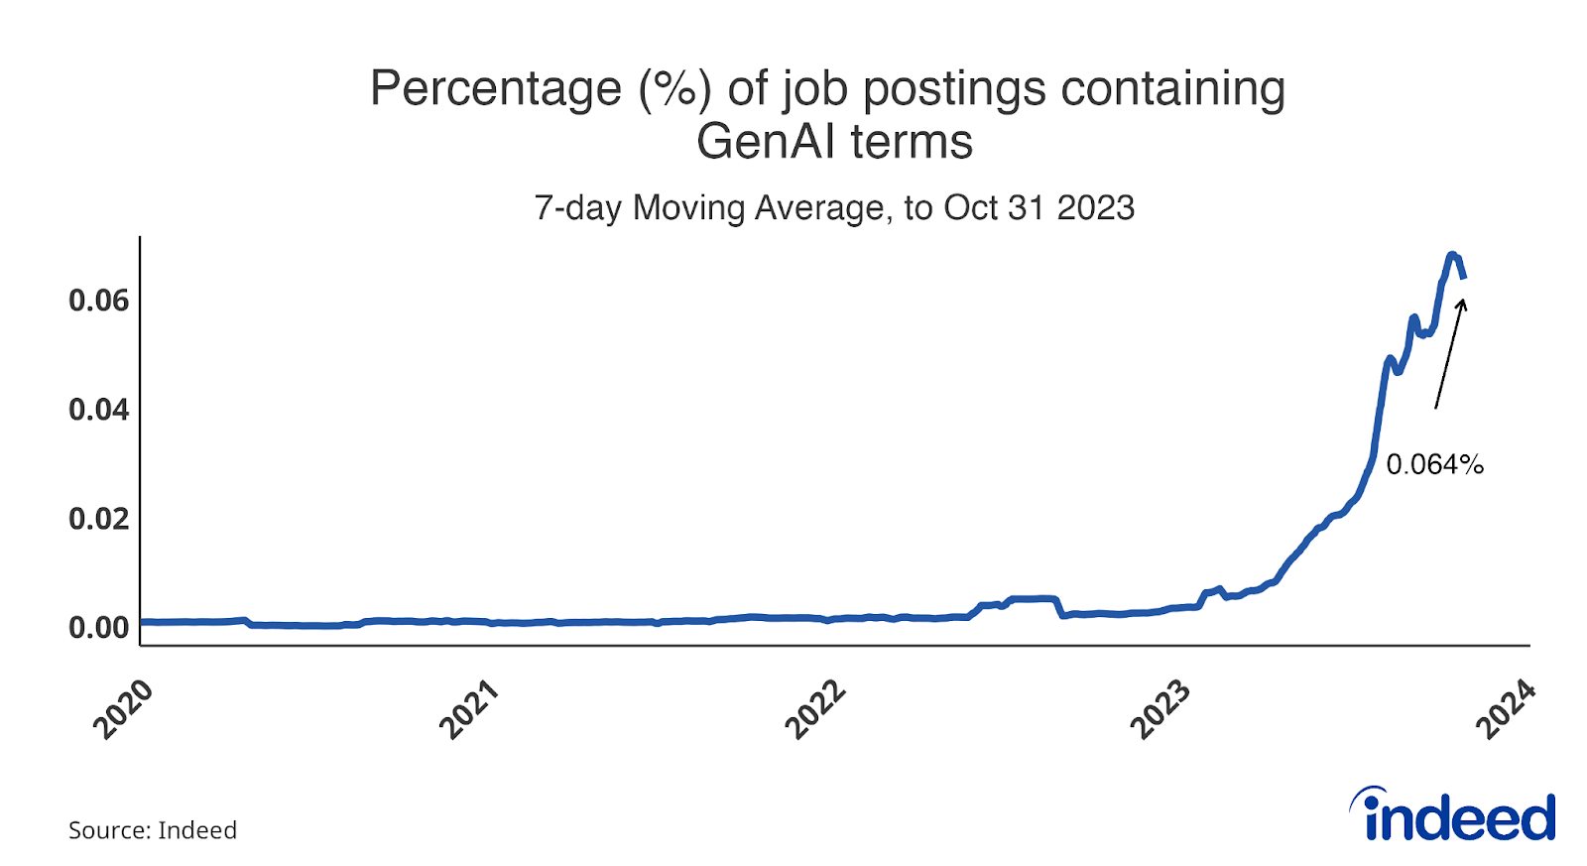
Data Source: Indeed, Job Employment Site

Impact of ChatGPT on Workforce

Are jobs at risks due to Chat GPT?
As many as 300 million full-time jobs around the world could be automated in some way by the newest wave of artificial intelligence that has spawned platforms like ChatGPT, according to Goldman Sachs economists.

While the new job creation rate has not seen a steady decline after the launch of ChatGPT and the job market has not been impacted by a great margin even after 16 months since the launch of the Generative AI Tool, it is crucial to understand that impact of generative AI in white collar jobs.

Important factors to consider while collecting data for measuring the impact of ChatGPT in the workforce includes
- Percentage of jobs that are vulnerable for AI Automation
- Categorize the jobs / job functions that have the potential to be replaced by Generative AI such as Administrative Jobs, Clerks/Paralegal Assistants Jobs at Law office, etc.,

It is also important to note that there appears to be no correlation between Job Creation/Unemployment Rate and ChatGPT at this point. (even though revenue details of OpenAI is not known, we can infer the results through Job Creation/Unemployment Rate)

Data Source: U.S. Bureau of Labor Statistics

Data Source: U.S. Bureau of Labor Statistics

An alternative way to look at the impact of ChatGPT in Workforce is to understand who we can leverage the power of Generative Tool by openly implementing the tool in business and free up workforce to focus on non-trivial and core business tasks.

What percentage of workforce are familiar with ChatGPT?

With over 88% of American Workforce having some degree of familiarity over ChatGPT (57% Very familiar and have used it and 31% are somewhat familiar but have not used it) (Brooks, 2023), it is easy to train the workforce and introduce ChatGPT in an organization.

Data Source: Business.com

With around 62% of Junior Management workforce have tried out ChatGPT, it will be easy to transition uncomplicated, repetitive tasks to ChatGPT and free up the time involved in these tasks to upskill the junior level workforce related to core business function.

Data Source: Business.com

Investing in ChatGPT for better outcome in Healthcare

OpenAI introduced the latest iteration of its language model, GPT-4, with the added capability of processing visual inputs. This advancement holds particular significance for medical professionals. AI algorithms could potentially detect patterns and anomalies in medical images such as X-rays, MRIs, and CT scans that might elude human observation. This illustrates how AI has the potential to enhance precision in medical diagnoses and expedite the diagnostic timeline, ultimately enabling earlier interventions, more precise diagnoses, and better patient outcomes.
Other areas of healthcare that could get benefitted by Generative Ai includes
- Maintaining Patient Records – Family Health History, Current Medication, Medical History of Patients, Symptoms, Lab Results
- Automating Administrative Functions – Health Insurance Prior Authorization, Appeals for Claim Denial, Medical procedures documentation, etc.,
- Measuring reaction/progress to treatment/medication/diets

In 2022, the Global Generative AI in Healthcare Market was valued at USD 0.8 billion and is expected to be valued at USD 17.2 billion in 2032. Between 2023 and 2032, this market is estimated to register the highest CAGR of 37%.

Data Source: Forecast by Precedence Research Firm

Guaranteeing the quality and safety of AI-generated outputs is paramount, especially in applications like diagnosis, treatment planning, or drug discovery within healthcare. Robust validation, testing, and adherence to regulatory approval processes are essential to ensure the dependability and safety of AI-powered healthcare solutions (Atreya, 2023).

Limitation and Ethical Concerns about ChatGPT

Major limitations of ChatGPT (and in general, any Generative AI tool) includes

- Creativity: Despite of training dataset, rigorous training models and Machine Learning techniques, ChatGPT or any other Generative AI tool will lack the creative thinking
- Bounded Knowledge: Ability/Knowledge of ChatGPT is directly proportionate to the underlying Dataset that is used to train the model. ChatGPT will not be able to answer questions around the topic that are not available in training dataset
- Cognitive Ability: ChatGPT do not have thinking ability and therefore it is possible that the tool will provide incorrect or inaccurate information as a result of technology glitch and the tool might not realize the error

Ethical issues surrounding ChatGPT are significant and plenty, some of the major ones includes

- Privacy – There is potential for identification of individual’s private information if the anonymization is not done properly, it might lead to reputational damage, security concerns, target the individuals for advertisement, etc.,
- Discrimination – If not carefully handled, Generative AI tools will unintentionally inherit the bias from the underlying dataset or even the Machine Learning programs will induct the bias based on the data
- Transparency – The accuracy of ChatGPT's responses is increasing, but users won't be able to access the data or metadata used to generate the information. This lack of access hampers transparency, making it difficult for users to comprehend the reasoning behind the results

Next Chapters for ChatGPT

Generative Pre-trained Transformer 4 is a multimodal large language model created by OpenAI, and the fourth in its series of GPT foundation models. It is made public in March 2023 and it is available through a subscription to the tool, ChatGPT Plus. The GPT-4 helps provide more nuances and accurate response, GPT-4 can provide up-to-date information since it has the ability to connect to Internet. It possesses multimodal compatibility and this enables GPT-4 to interpret text from other media format such as images, audit and video. GPT-4 with its image, audio and video compatibility makes it much more robust in areas such as reading, interpreting and storing medical transcript that are hand-written, analyze scripts, texts that are not digitized, etc., It has increased capacity for input and output of 25000 words per interaction. GPT-4 was built on top of a bigger training dataset (trained close to 100 trillion parameters).
While these new features add value to the Generative AI tool, GPT-4 can still provide an incorrect response. It is possible for malevolent actors to use the tool for evil intentions. The increase in volume of training dataset makes the tool even more complex and it might make it harder to comprehend the responses provided by the tool.

Findings

It is conspicuous that ChatGPT and its future version will impact the world, it is important to analyze the what the impact is and how we can take advantage of the potentials of ChatGPT and how to mitigate through the risks and issues. It is clearly evident that ChatGPT have a positive impact in streamlining business processes or in general helping businesses through the ChatGPT revenue estimates and job opportunities involving the Generative AI skillsets.

There are clear indications of the impact on workforce with certain job types are at the risk of replacement by ChatGPT, we have observed that job creation and unemployment rates have not been impacted much. This helps us thinking about alternative approach where we can tap the potentials of the Generative AI tools and free up the junior level workforce to upskill with core business related skills.

We have also noticed the market potentials of Generative AI in healthcare sectors and how carefully implementing ChatGPT in the healthcare industry will help healthcare professionals focus on critical tasks while trivial tasks can be automated through the Generative tool. We have also highlighted the fact the ChatGPT can never replace the nuance of a medical professionals and the drawback/risks posed by ChatGPT in healthcare industry.

We have observed the potentials of the latest version of the ChatGPT, GPT-4 and how it is trained on a larger dataset. It also can read from media formats such as Video, Audio and Images which advances the use cases of the Generative AI tools. We have also seen the new version of the ChatGPT can connect to the internet and can provide up to date response when compared the previous version that had the limitation of scope, i.e. the training data set.

Assumptions
One of biggest assumptions made by individuals and entities using ChatGPT is that they believe the output of ChatGPT is accurate. There are cases reported about ChatGPT producing assumed output rather than referencing materials from training dataset including holidays, entity specific schedule/policies. Assumptions have been made in the healthcare sectors, for example – ChatGPT making false diagnosis and provided related support documents/studies when it could not diagnose the actual conditions and symptoms. In the absence of specifics in the query or missing details in the query, ChatGPT has been observed to make significant assumptions that helped the tool provide output from training datasets.

Ethical Concerns
Using ChatGPT raises significant ethical concerns across social justice, individual autonomy, cultural identity, and environmental issues and major issues such as accountability, bias, safety, autonomy, and social cohesiveness (Stahl, 2024). In particular to this study, there are some serious concerns that needs to be address including using ChatGPT in business there is a definite impact to the workforce, using ChatGPT in HealthCare sector, it is possible for business take advantage of the feature to overlook critical observation/nuance that can only be made healthcare professionals, and in general, the accuracy of output depending upon the dataset which could include Bias and the subsequent result derived from the dataset having potential to impact a section of community/geographical regions.

Challenges/Opportunities
Opportunities are plenty for ChatGPT including automating repetitive trivial tasks, providing security recommendation, perform risk analysis on various sectors such as finance, insurance, healthcare, etc., Identifying patterns that are not obvious to human interpretation, preventing cybercrimes, perform predictive analytics, availability (24/7 accessibility) for product support, augmenting educational resources.
Challenges faced by ChatGPT includes Academic Integrity, Resource Constraint (often limited to underlying training Datasets), Bias and Fairness, Accountability, Transparency (in computation of results for a problem/question), legal and regulatory compliance (adapting to latest policy enforcements from Governments across the globe), balancing human expertise with automation.

Conclusion
In essence, ChatGPT is changing the world by improving communication, efficiency, enabling new applications, and increasing accessibility. As AI language models progress and refine, their ability to influence our lives and work is expected to grow dramatically in the years to come. We can fully realize the potential of Chat GPT by solving ethical challenges, reducing bias, promoting justice, upskilling the workforce, and preserving user privacy. Whether the goal is to improve customer happiness, stimulate innovation, or maintain a competitive advantage, ChatGPT emerges as a solution that businesses of all sizes should consider incorporating into their plans to achieve their overall goals.

References

- Must-Know Chat GPT-4 Statistics [Recent Analysis] • Gitnux. (n.d.). Gitnux.org. Retrieved March 30, 2024, from https://gitnux.org/chat-gpt-statistics/#:~:text=Chat%20GPT%20is%20attracting%20an
- Duarte, F. (2023, March 30). Number of ChatGPT Users (2023). Exploding Topics. https://explodingtopics.com/blog/chatgpt-users#
- Your 7 Biggest ChatGPT Questions, Answered. (n.d.). Gartner. https://www.gartner.com/en/articles/your-7-biggest-chatgpt-questions-answered
- The Future of AI: How Will Chat GPT Change The World? (2020). Learn about Technology with TDK. https://www.tdk.com/en/tech-mag/past-present-future-tech/what-is-chat-gpt#section6
- Is Chat GPT changing the world? (2019). Quora. https://www.quora.com/Is-Chat-GPT-changing-the-world#:~:text=Here%20are%20some%20of%20the
- The Consequences of Chat GPT - Transforming Society and the Professional World. (n.d.). Www.linkedin.com. Retrieved April 19, 2024, from https://www.linkedin.com/pulse/consequences-chat-gpt-transforming-society-world-jaliawala-acca-/
- With Little Employer Oversight, ChatGPT Usage Rates Rise Among American Workers. (n.d.). Business.com. https://www.business.com/technology/chatgpt-usage-workplace-study/
- ‌Staff, E. (2023, February 17). What Does ChatGPT Mean for the Future of Business? Entrepreneur. https://www.entrepreneur.com/science-technology/what-does-chatgpt-mean-for-the-future-of-business/445020
- ‌Curry, D. (2023, February 9). ChatGPT Revenue and Usage Statistics (2023). Business of Apps. https://www.businessofapps.com/data/chatgpt-statistics/
- Bunker, N. (2023, November 15). Indeed’s 2024 US Jobs & Hiring Trends Report. Indeed Hiring Lab. https://www.hiringlab.org/2023/11/15/indeeds-2024-us-jobs-hiring-trends-report/
- Chat GPT and AI in healthcare: Just what the doctor ordered? (2023, April 26). Www.simon-Kucher.com. https://www.simon-kucher.com/en/insights/chat-gpt-and-ai-healthcare-just-what-doctor-ordered
- ‌ ChatGPT: Health care’s next big thing? (n.d.). MedicalEconomics. https://www.medicaleconomics.com/view/chatgpt-health-care-s-next-big-thing-
- Generative AI In Healthcare Market Size, Growth Report 2032. (n.d.). Www.precedenceresearch.com. https://www.precedenceresearch.com/generative-ai-in-healthcare-market
- ‌Atreya, S. (2023, June 12). The Applications of Generative AI in Healthcare with Its Medical Considerations | Cigniti. https://www.cigniti.com/blog/exploring-the-use-of-generative-ai-in-healthcare-and-medicine/#:~:text=Bias%20and%20fairness%3A%20Generative%20AI
- Toh, M. (2023, March 29). 300 million jobs could be affected by latest wave of AI, says Goldman Sachs | CNN Business. CNN. https://www.cnn.com/2023/03/29/tech/chatgpt-ai-automation-jobs-impact-intl-hnk/index.html
- Stahl, B. C., & Eke, D. (2024). The ethics of ChatGPT – Exploring the ethical issues of an emerging technology. International Journal of Information Management, 74(74), 102700–102700. https://doi.org/10.1016/j.ijinfomgt.2023.102700
- Challenges of Using ChatGPT. (n.d.). FasterCapital. Retrieved May 12, 2024, from https://fastercapital.com/startup-topic/Challenges-of-Using-ChatGPT.html
- Armitage, P. (2023, March 24). 5 Ethics Issues for ChatGPT and Design. The Fountain Institute. https://www.thefountaininstitute.com/blog/chat-gpt-ethics

